Q21
Write a program to display the month name and number of days using switch-case for a given month number.
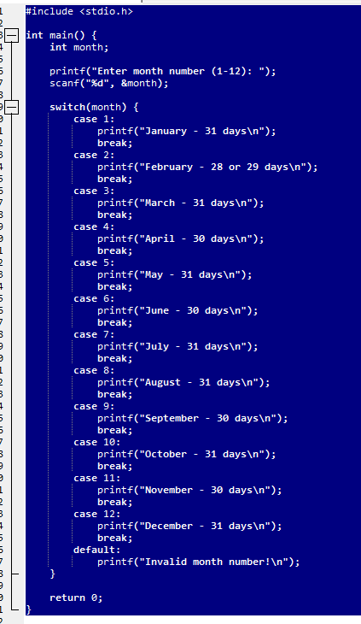
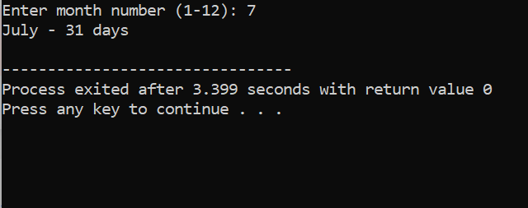
Q22Write a program to find profit or loss percentage given cost price and selling price.
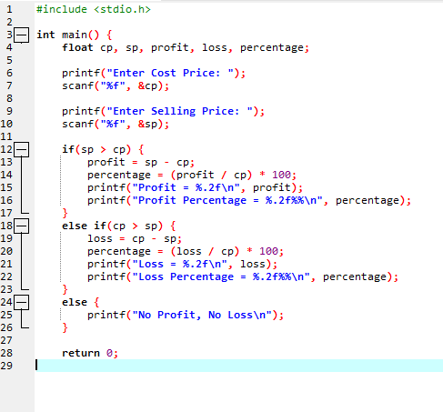
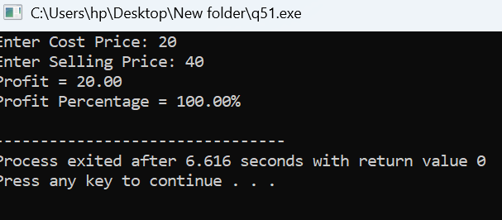

Q23 Write a program to calculate library fine based on late days as follows:
First 5 days late: ₹2/day
Next 5 days late: ₹4/day
Next 20 days days late: ₹6/day
More than 30 days: Membership Cancelled.
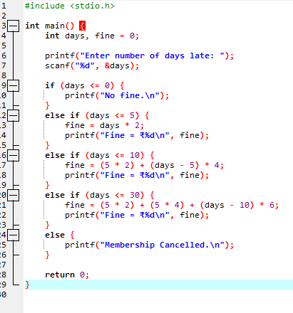
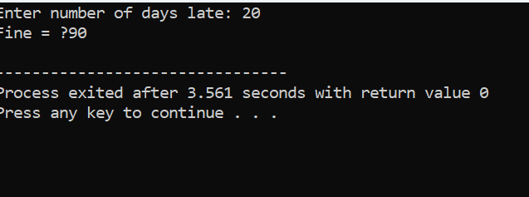
Q24Write a program to calculate electricity bill based on units consumed with these rates:
First 100 units at ₹5/unit
Next 100 units at ₹7/unit
Next 100 units at ₹10/unit
Above at ₹12/unit
